**13.ReactJS HOL Solutions**

**App.js**

import React from 'react';

import BookList from './components/BookList';

import BlogList from './components/BlogList';

import CourseList from './components/CourseList';

import { books, blogs, courses } from './data';

import './App.css';

function App() {

return (

<div className="container">

<CourseList courses={courses} />

<BookList books={books} />

<BlogList blogs={blogs} />

</div>

);

}

export default App;

**App.css**

.container {

display: flex;

justify-content: space-around;

padding: 20px;

font-family: Arial;

}

.list {

border-left: 3px solid green;

padding-left: 20px;

}

**data.js**

export const books = [

{ id: 101, bname: 'Master React', price: 670 },

{ id: 102, bname: 'Deep Dive into Angular 11', price: 800 },

{ id: 103, bname: 'Mongo Essentials', price: 450 },

];

export const blogs = [

{ id: 1, title: 'React Learning', author: 'Stephen Biz', content: 'Welcome to learning React!' },

{ id: 2, title: 'Installation', author: 'Schwezdenier', content: 'You can install React from npm.' }

];

export const courses = [

{ id: 1, cname: 'Angular', date: '4/5/2021' },

{ id: 2, cname: 'React', date: '6/3/2021' }

];

**BlogList.js**

import React from 'react';

function BlogList({ blogs }) {

return (

<div className="list v1">

<h1>Blog Details</h1>

{blogs.map(blog => (

<div key={blog.id}>

<h3>{blog.title}</h3>

<p><strong>{blog.author}</strong></p>

<p>{blog.content}</p>

</div>

))}

</div>

);

}

export default BlogList;

**BookList.js**

import React from 'react';

function BookList({ books }) {

return (

<div className="list s2">

<h1>Book Details</h1>

{books.map(book => (

<div key={book.id}>

<h3>{book.bname}</h3>

<h4>{book.price}</h4>

</div>

))}

</div>

);

}

export default BookList;

**CourseList.js**

import React from 'react';

function CourseList({ courses }) {

return (

<div className="list mystyle1">

<h1>Course Details</h1>

{courses.map(course => (

<div key={course.id}>

<h3>{course.cname}</h3>

<p>{course.date}</p>

</div>

))}

</div>

);

}

export default CourseList;

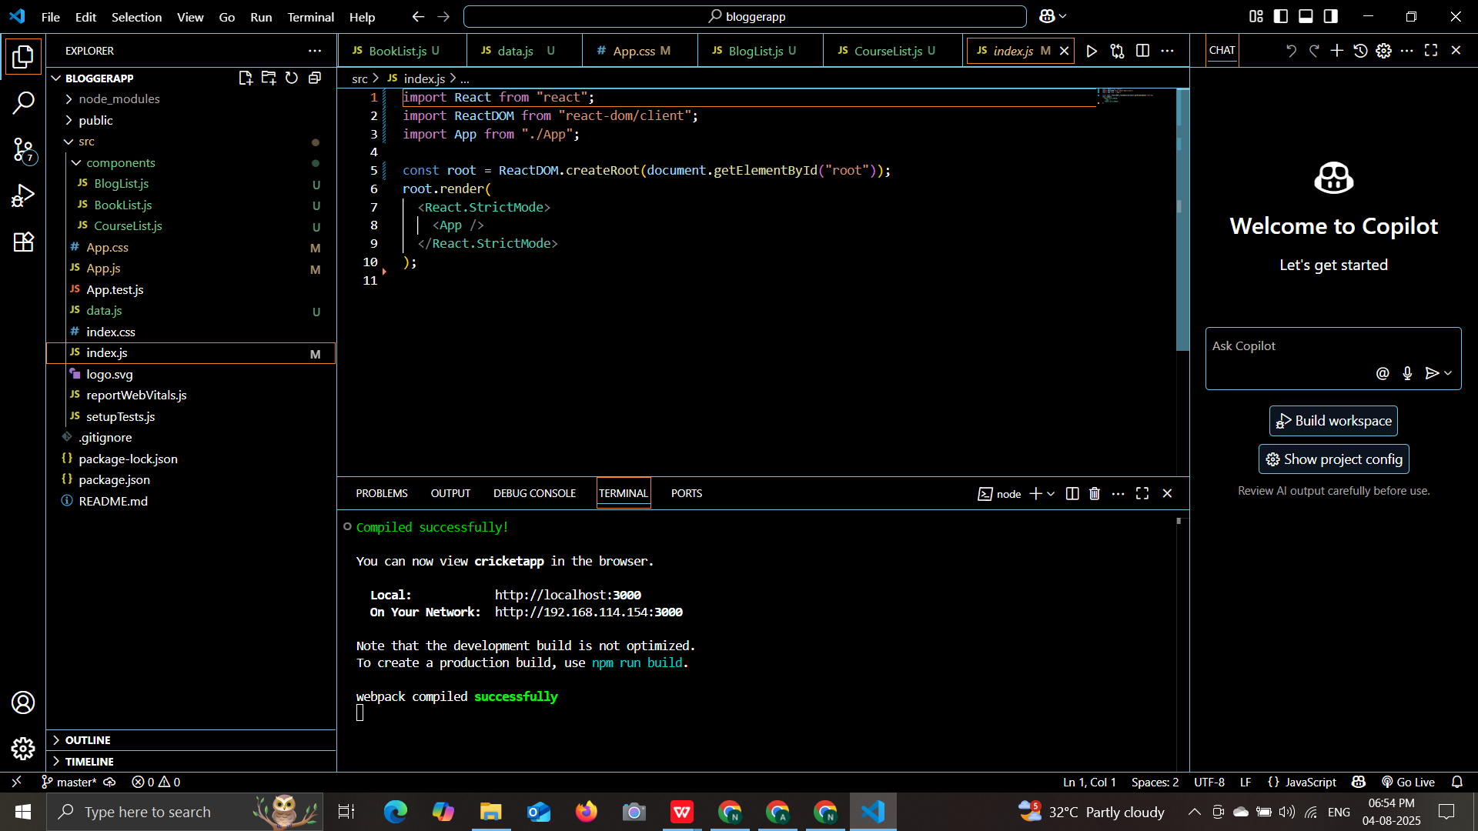

**OUTPUT:**

